## **SUPERMARKET SALES ANALYSIS**

**DESCRIPTION:**

The growth of supermarkets in most populated cities are increasing and market competitions are also high. The dataset is one of the historical sales of supermarket company which has recorded in 3 different branches for 3 months data. Predictive data analytics methods are easy to apply with this dataset.

**IMPORTING LIBRARIES AND READING DATA:**

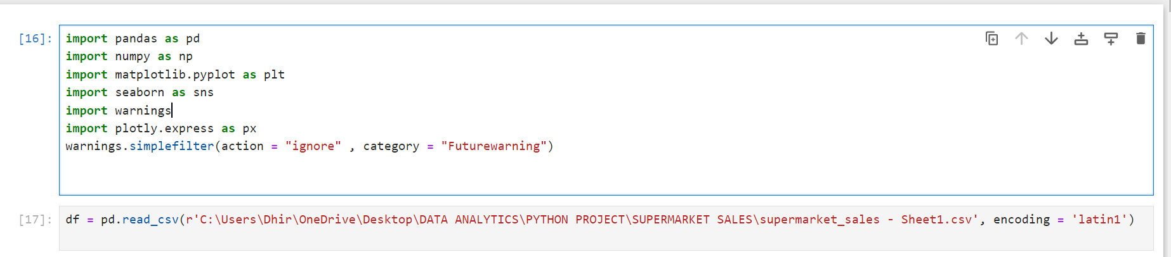

**DATA EXPLORATION:**

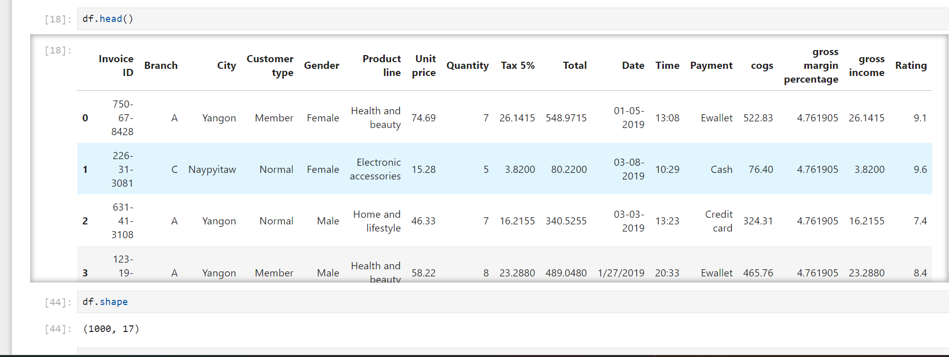

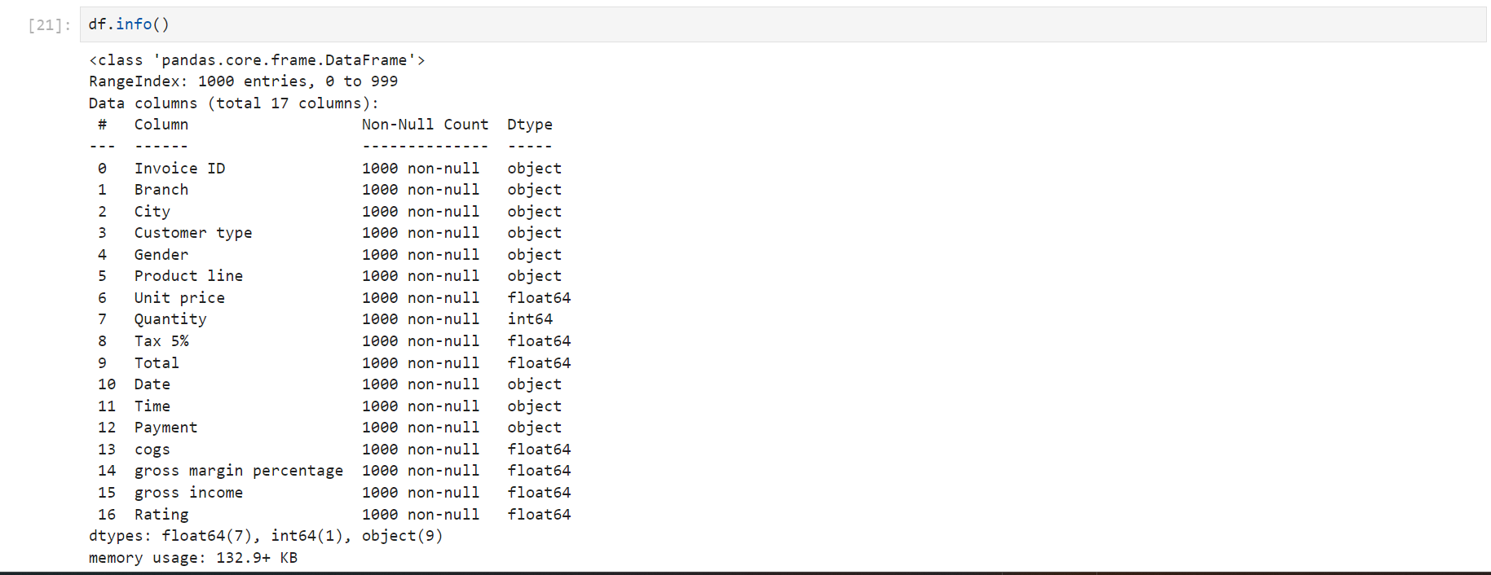

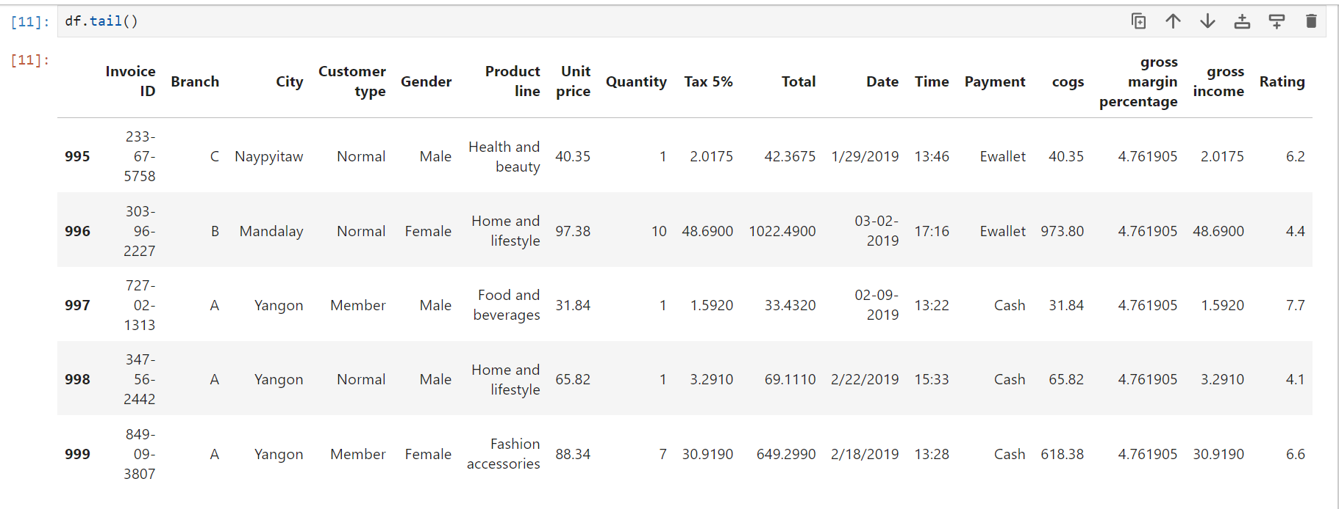

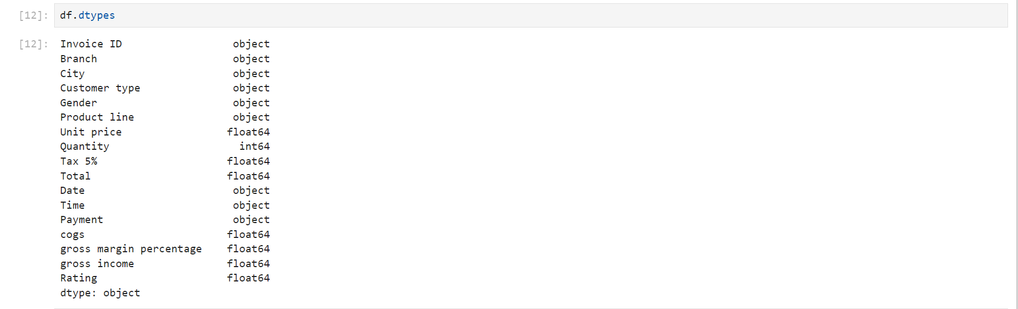

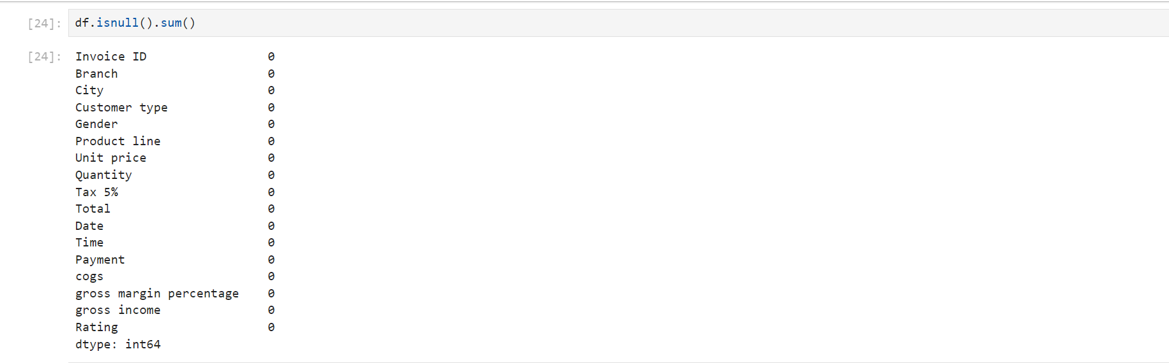

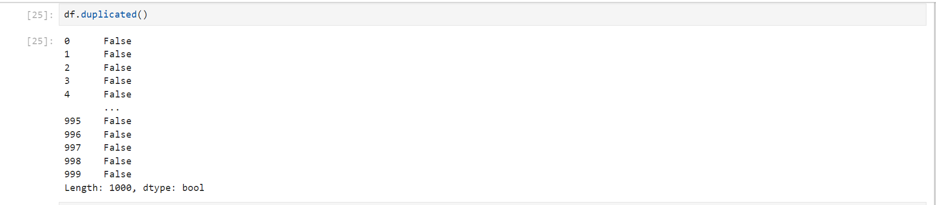

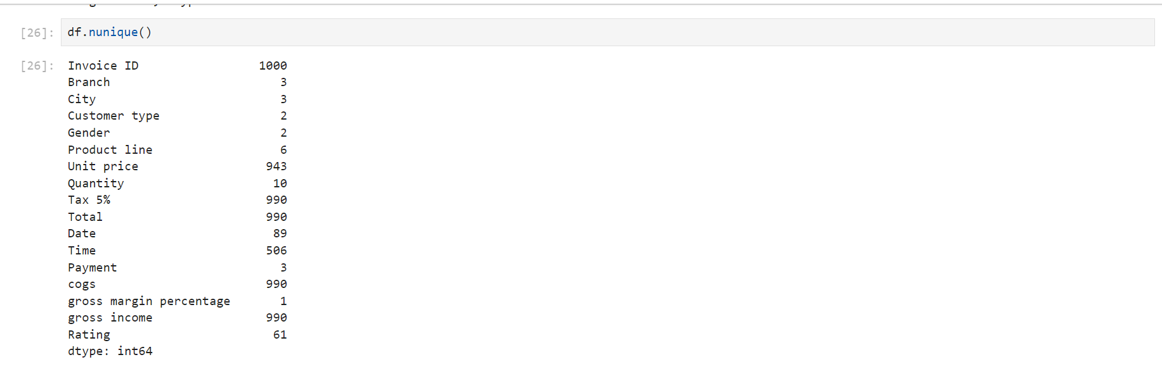

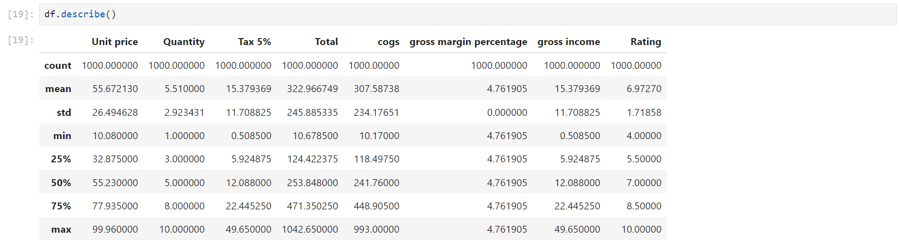

**DATA CLEANING:**

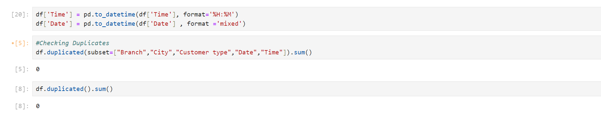

**ADDING EXTRA COLUMN FOR FURTHER ANALYSIS:**

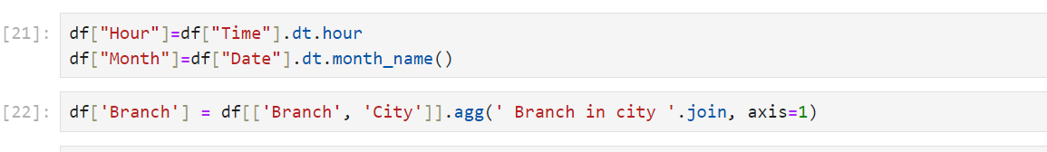

**UNIQUE VALUES IN EACH CATEGORICAL COLUMN:**

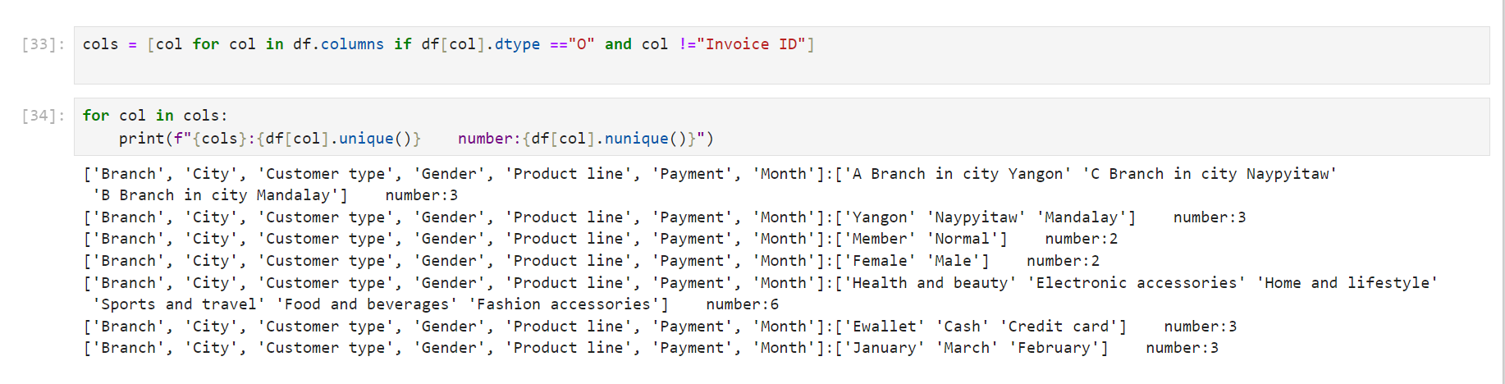

**GAPHICAL REPRESENTAION OF CATEGORICAL VALUE:**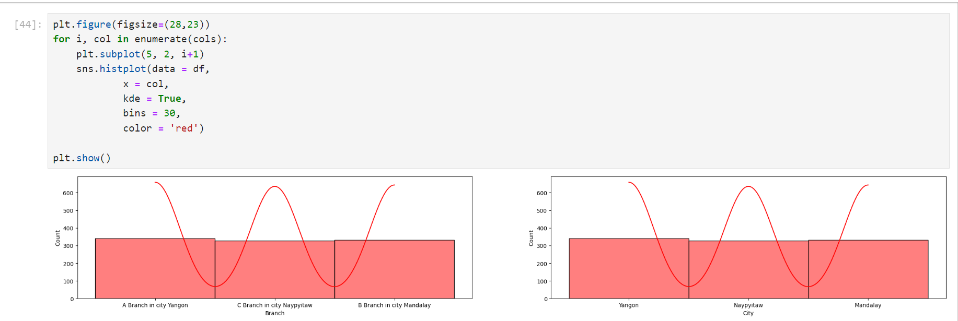

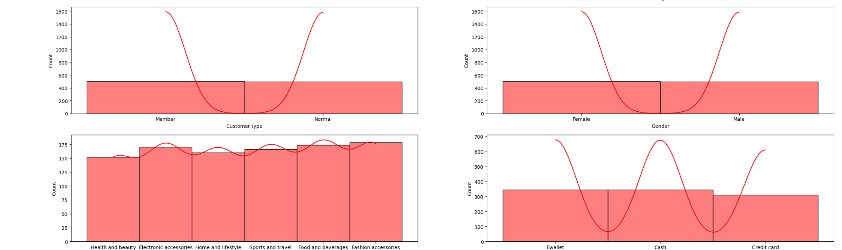

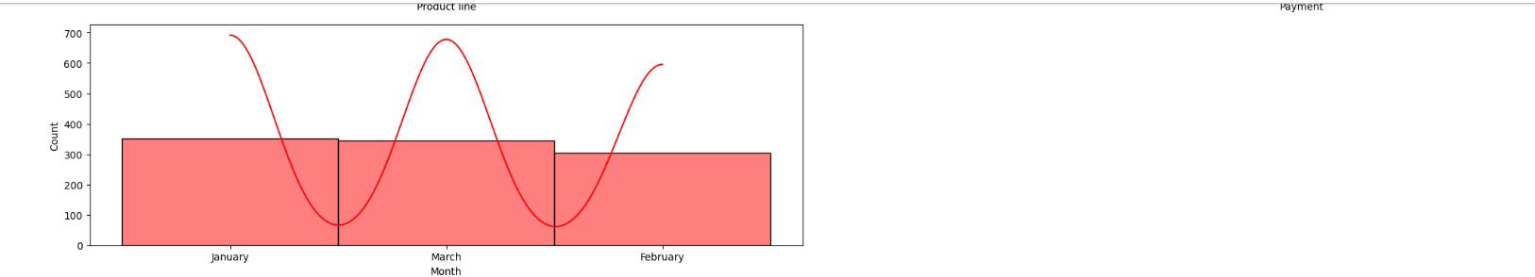

**ANALYSIS OF EACH BRANCH:**

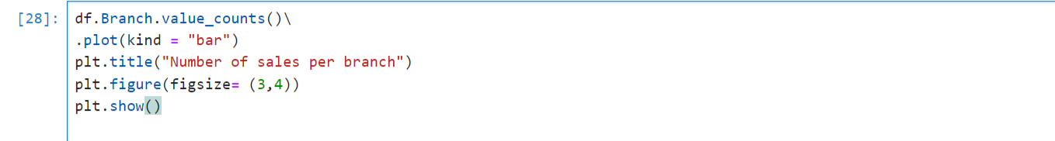

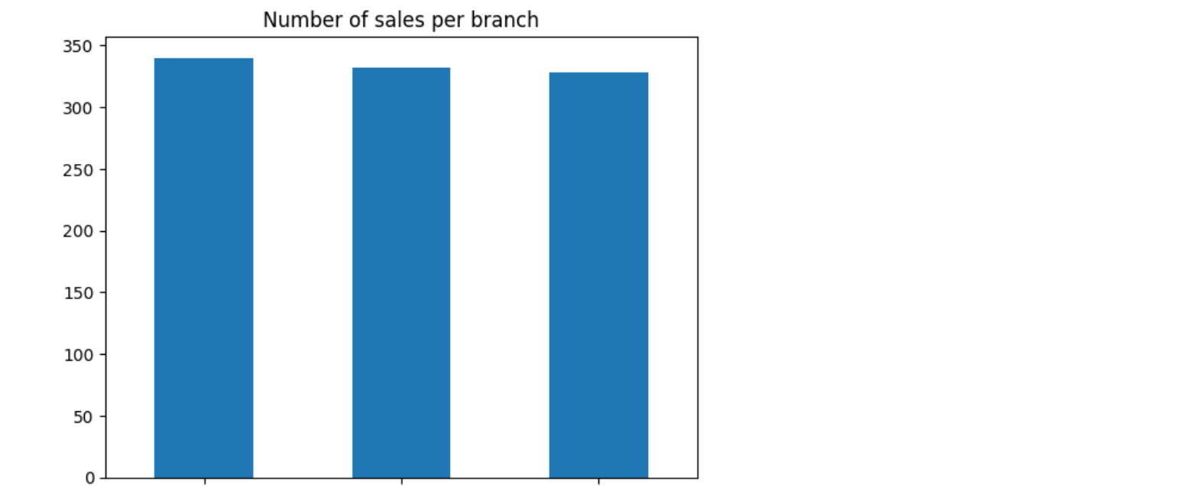

A B C

Branch in city Branch in city Branch in city

Yangon Mandalay Naypyitaw

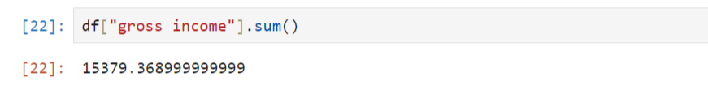

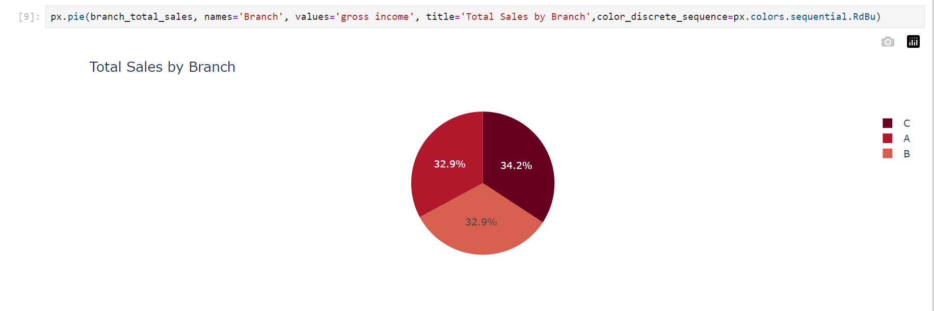

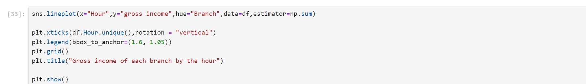

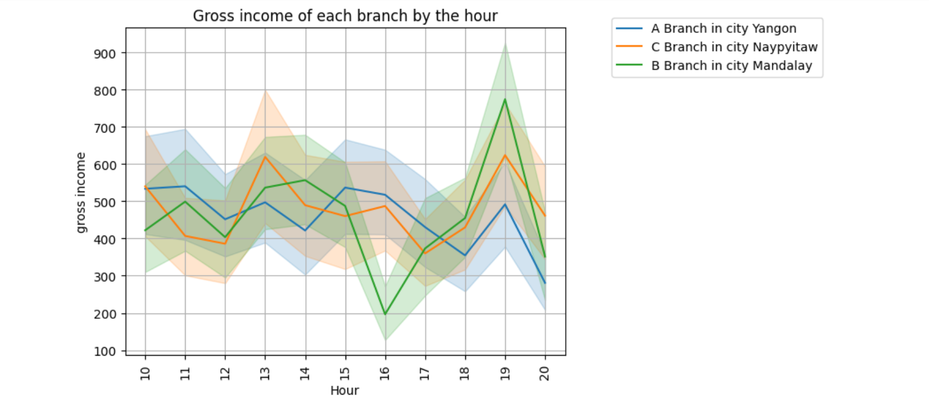

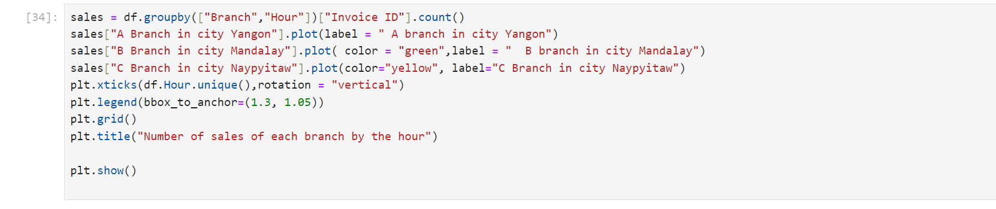

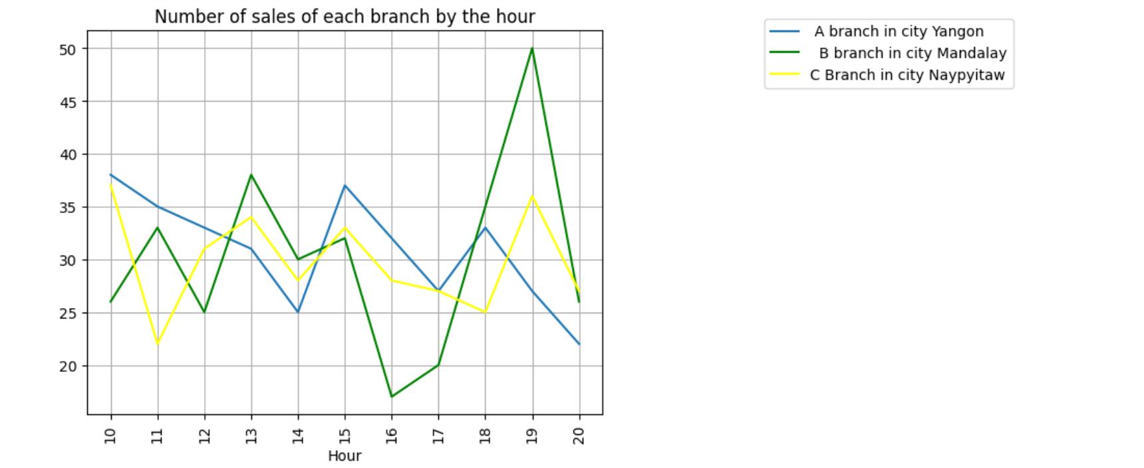

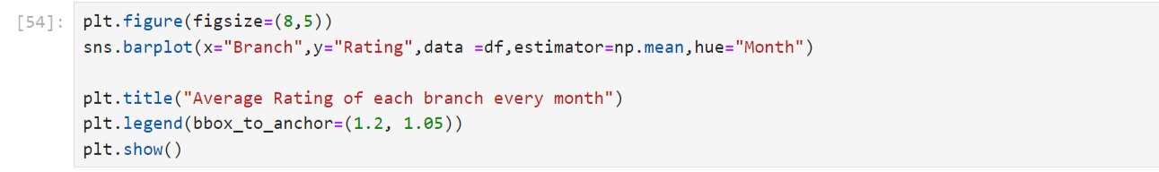

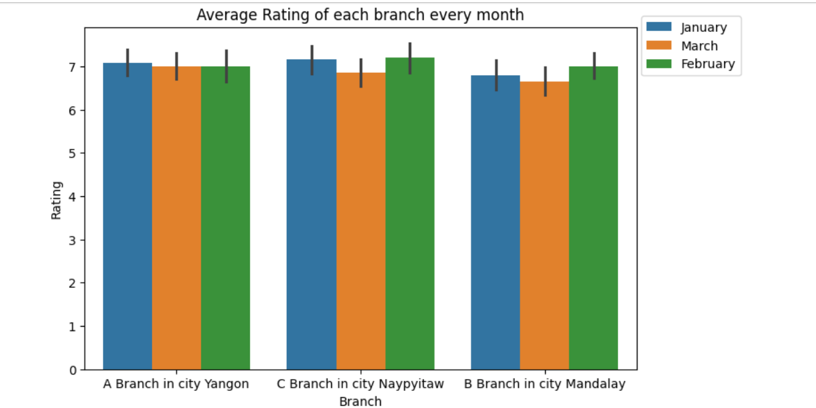

* From the graphs above we can see that branch B has lower average rating than the other 2 branches
* All the branches are pretty close to each other in term of gross income with branch C doing a little bit better
* Most sales and Gross income happen at hour 19 and are low at hour 16

**WHICH CUSTOMER TYPE SPENDS MORE ON AVERAGE?**

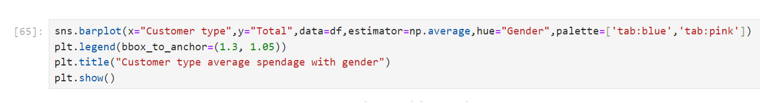

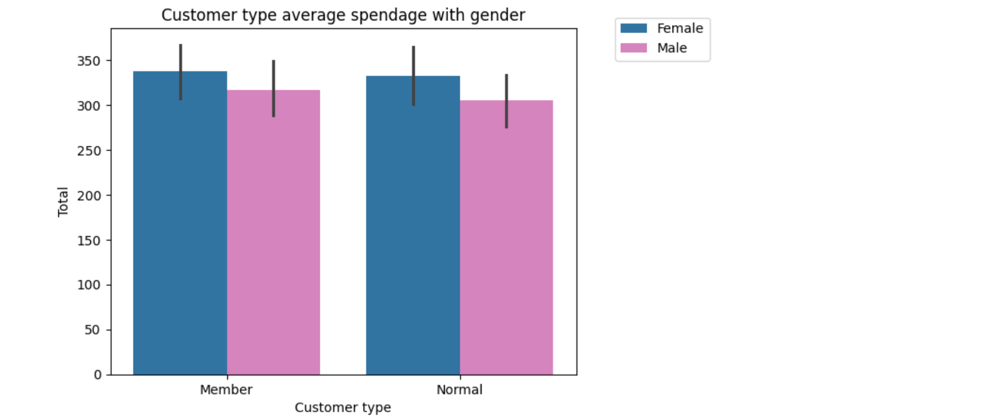

* From the above graphs we can see that females tend to spend more than males and buy more
* Members tend to spend more money than normal customers.

**PRODUCT LINE ANALYSIS:**

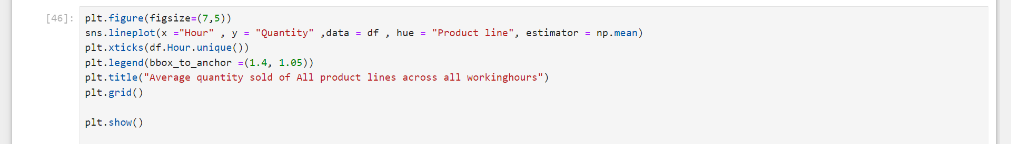

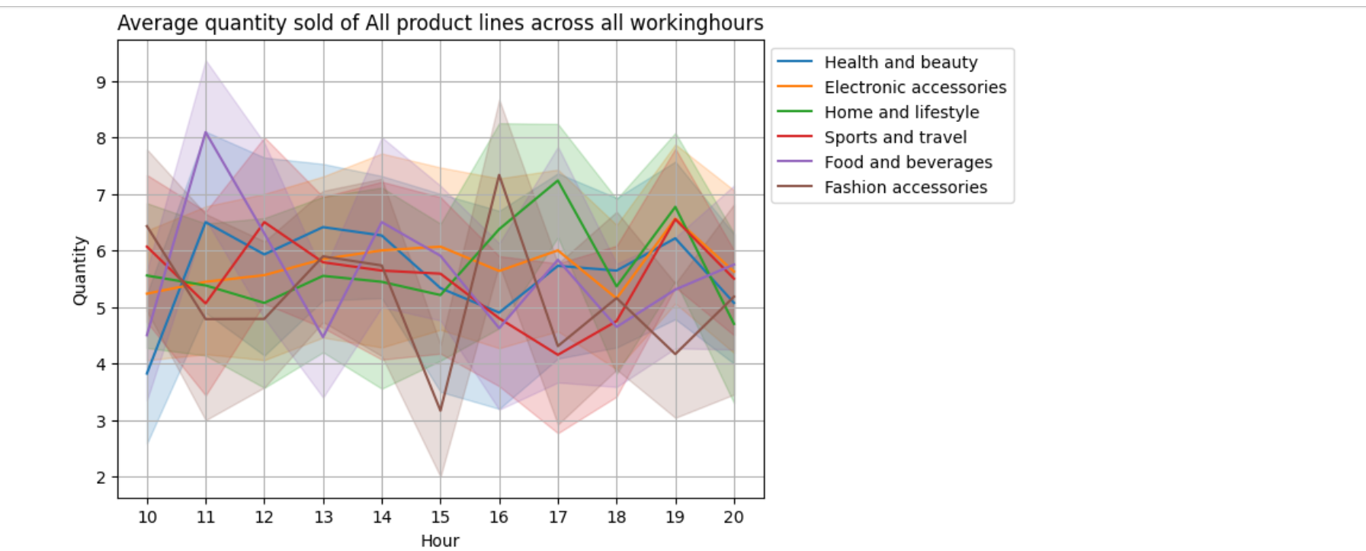

Here we can see that each product line has its own hour where sales is at the highest such as:

* Hour 11 for Food and beverages and Health and beauty
* Hour 19 for electronic accessories and sports and travel
* Hour 17 for Home and lifestyle
* Hour 16 for fashion accessories

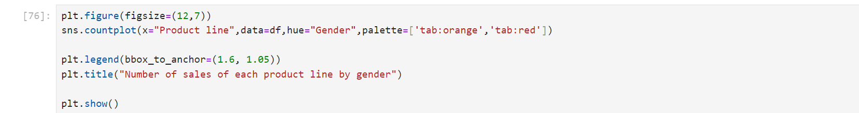

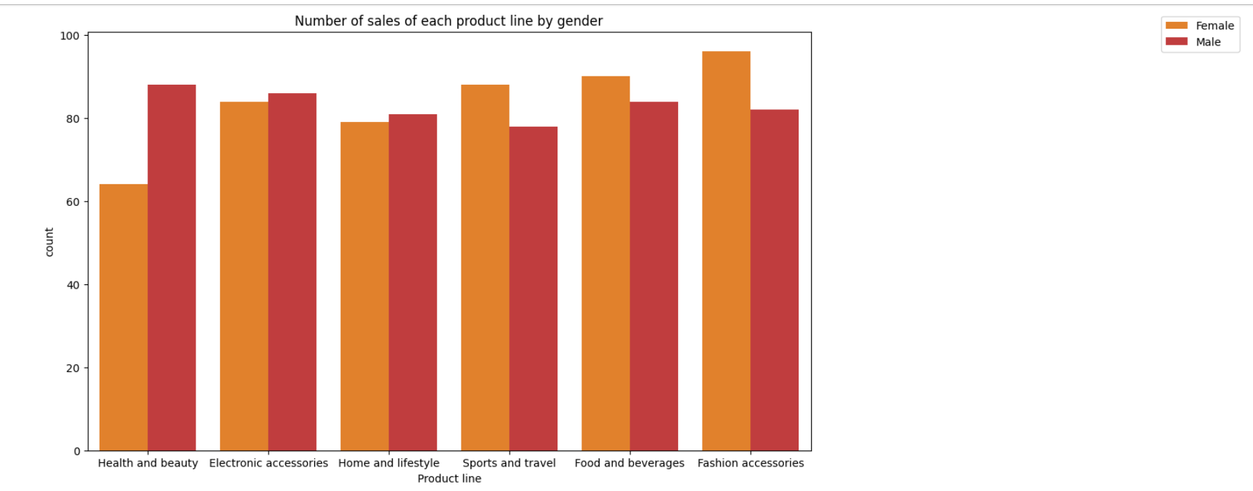

* Here we find that females buy more than males in Fashion accessories, Food and beverages and sports and travel while males buy more in Home and lifestyle, electronic accessories and health and beauty

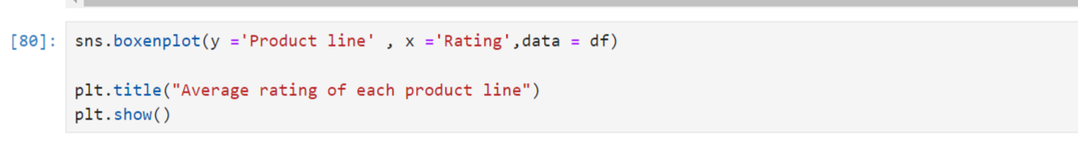

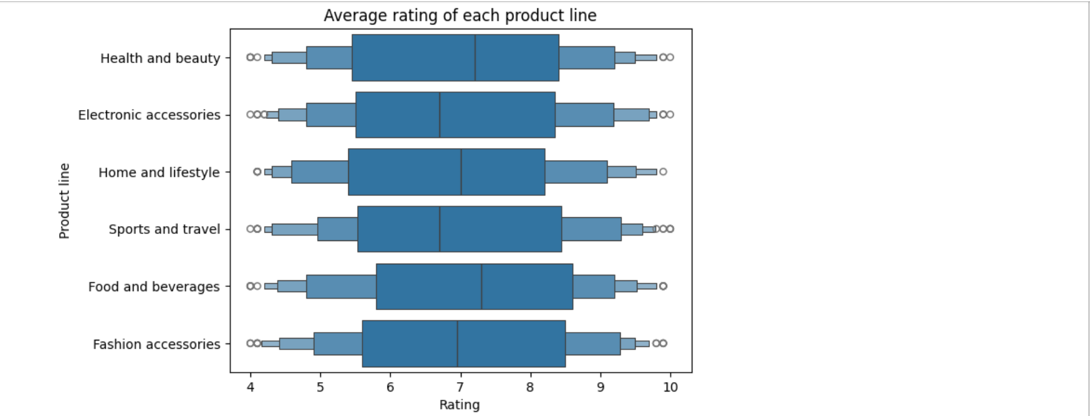

* The highest average rated product line is Food and beverages followed by Health and beauty while the lowest is sports and travel followed by electronic accessories

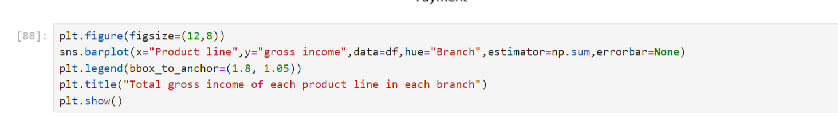

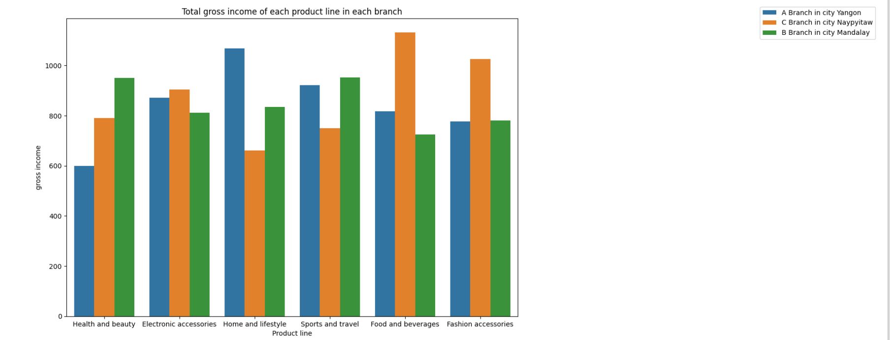

* In branch A the highest product line in gross income is Home and lifestyle while the lowest is health and beauty
* In branch B the highest product line in gross income is Health and beauty followed closesly by sports and travel while the lowest is food and beverages
* In branch C the highest product line in gross income is Food and beverages while the lowest is Home and Lifestyle

**ANALYSIS OF PAYMENT CHANNELS:**

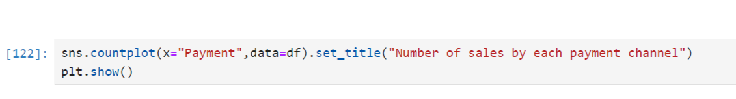

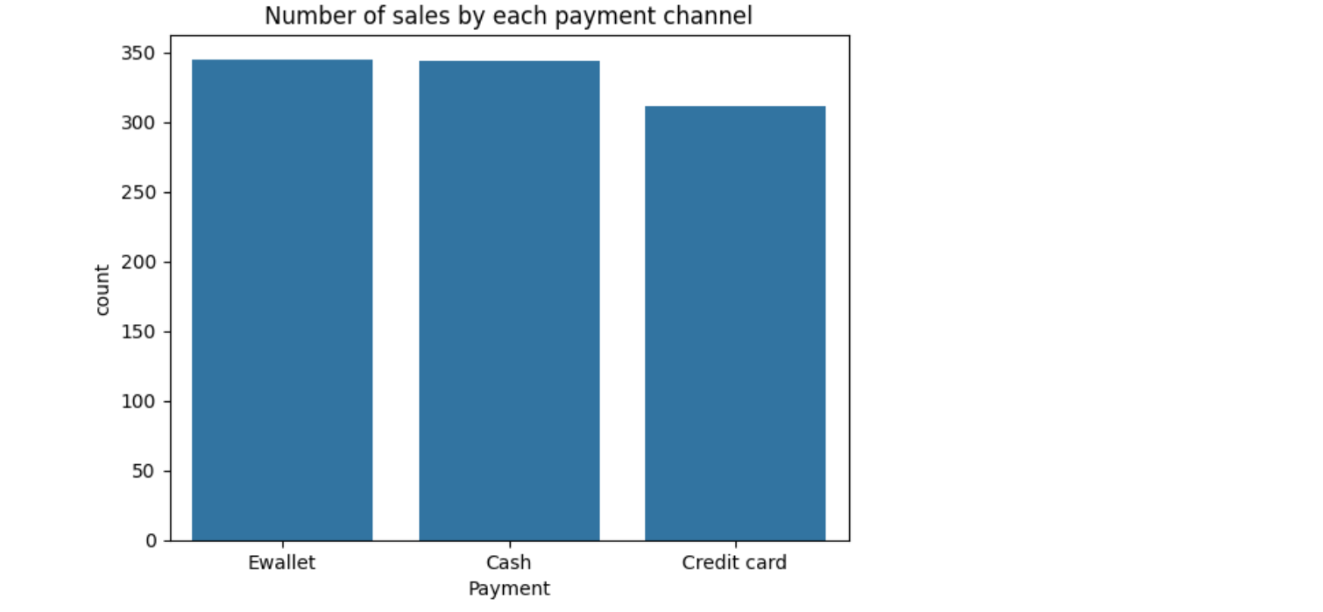

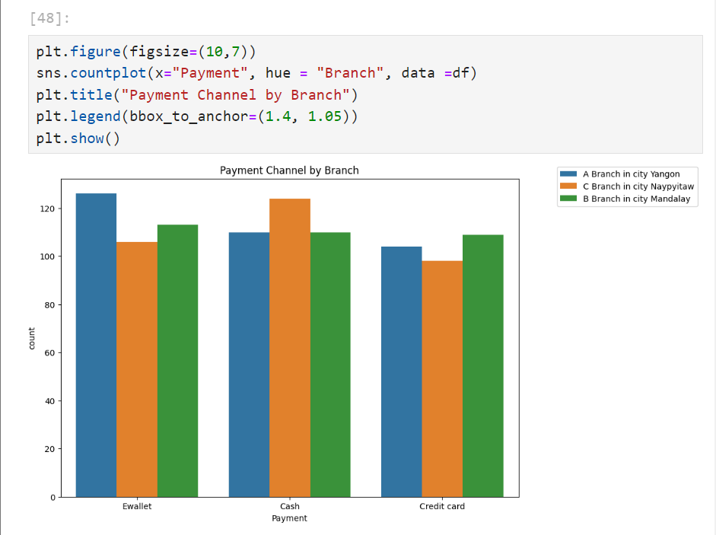

* From the graphs above we see that the overall most used payment channel is E-wallet followed by cash and then credit card
* However, in Branch C Cash is used more than E-wallet and credit card

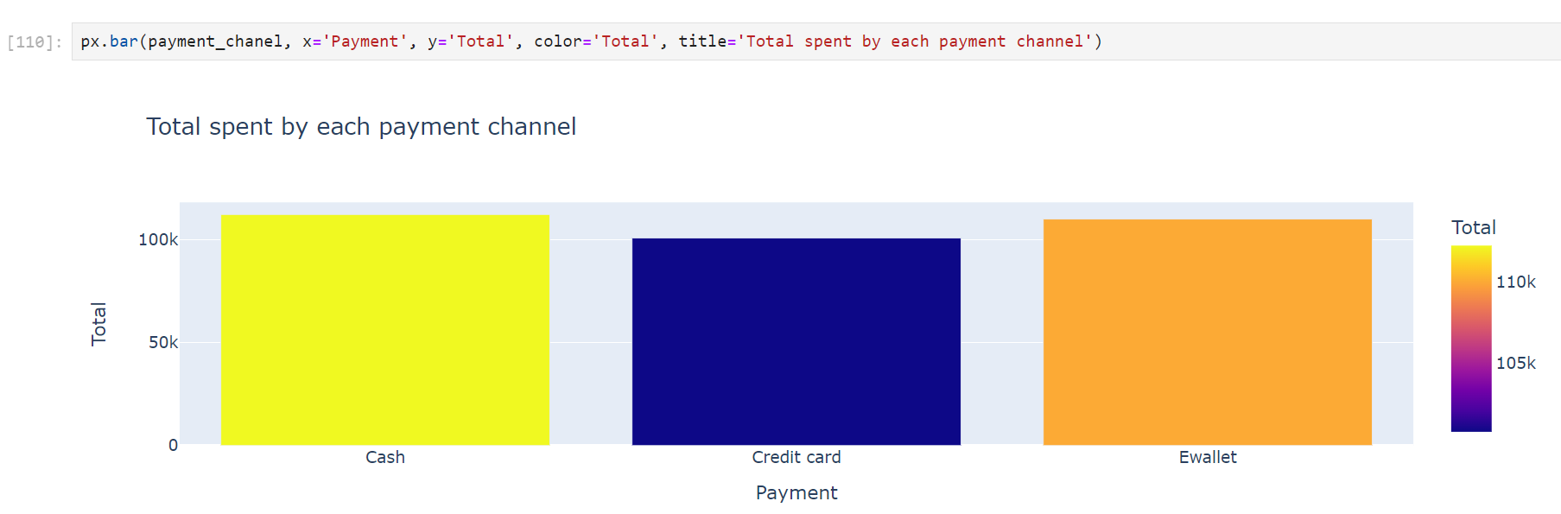

* From the graph above we see that cash and credit card users tend to spend a bit more than E-wallet

**ANALYSIS OF SALES:**

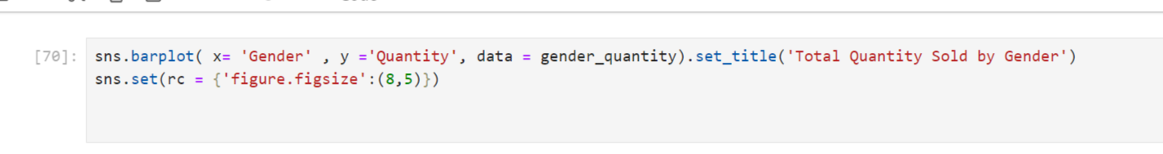

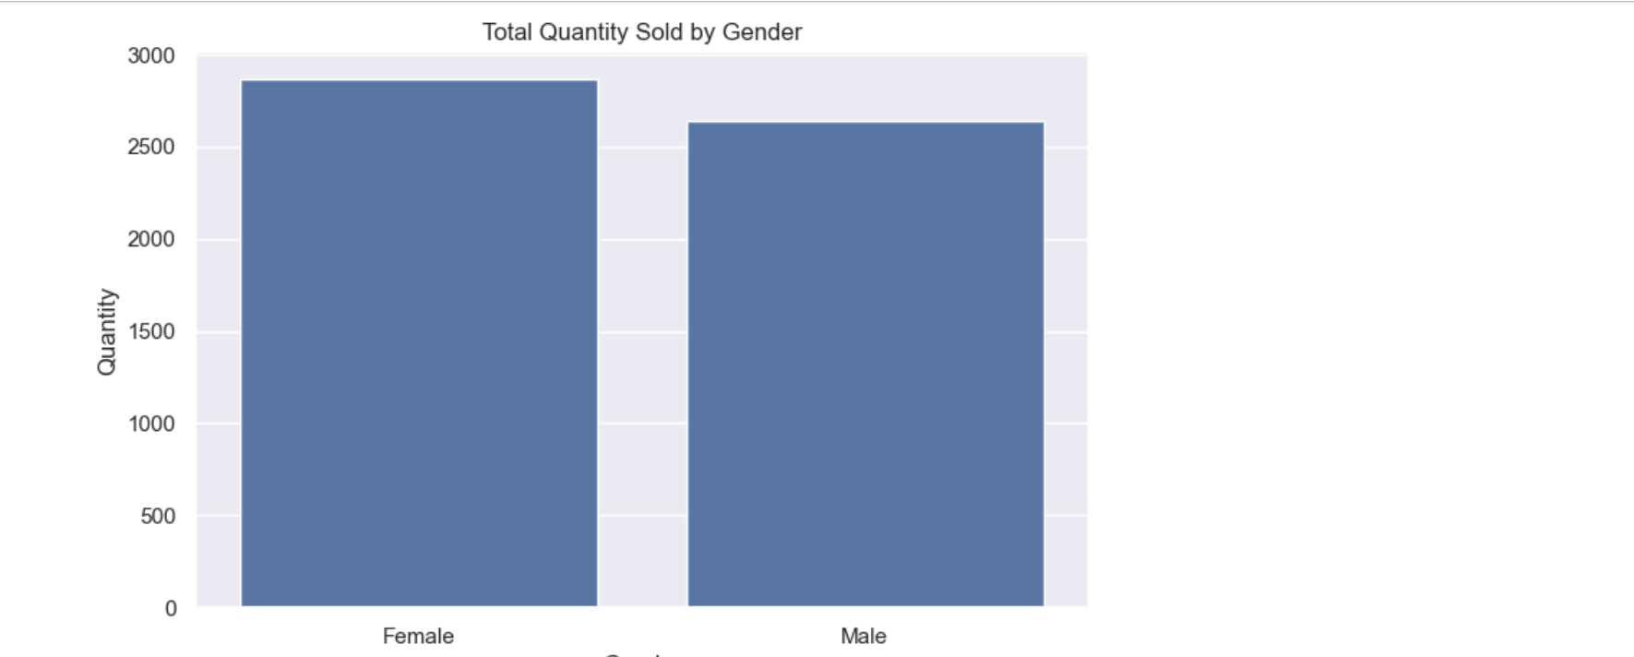

* From the graph we see that the most of the quantity sold to female

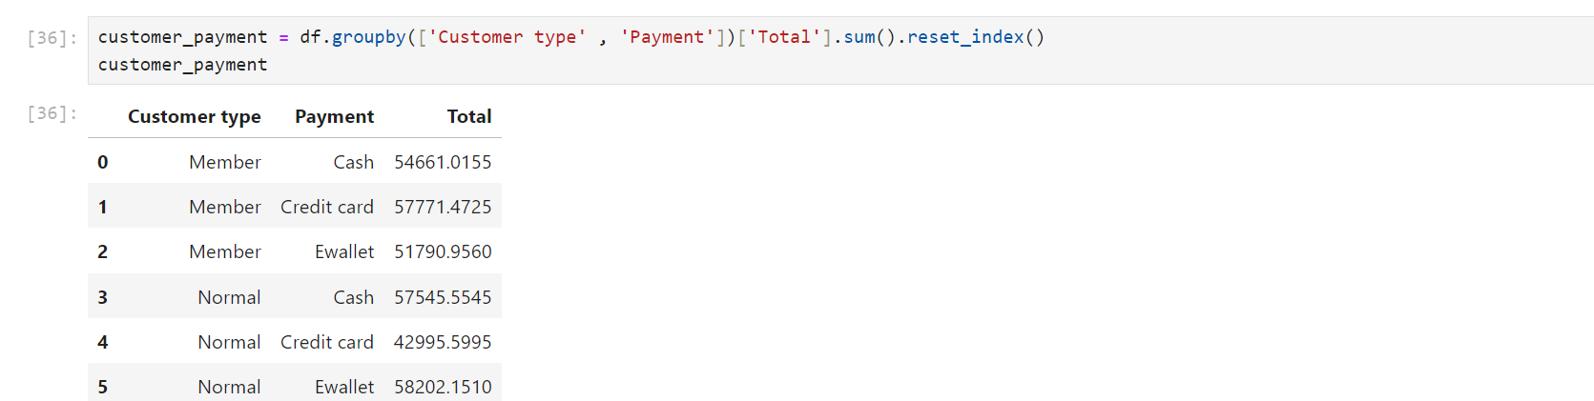

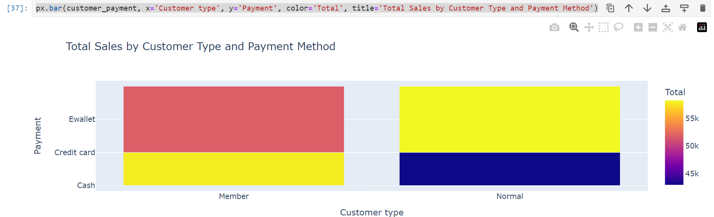

* From the graph we can see that member and normal do most of the payment through E-wallet.

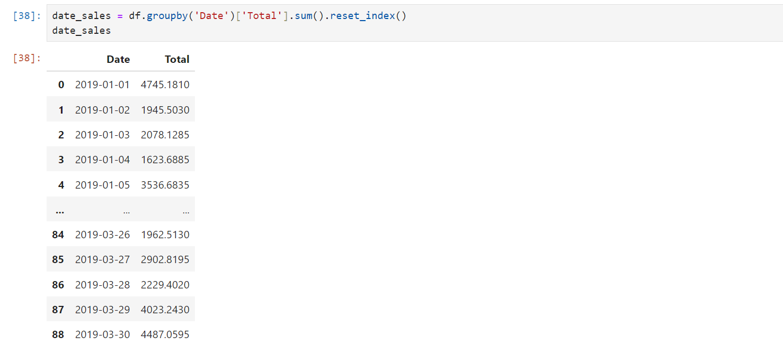

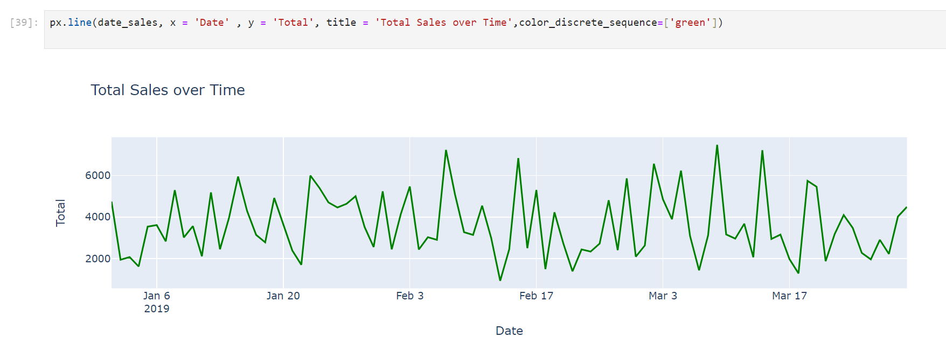

* From the line chart we can see that the sales get increase on March 9,2019.

**THANK YOU**